MySQL Assignment 6

Sorting and Grouping Data

Q)

1. Write an SQL query to print the first three characters of Country_name from the Country table.

2. Write an SQL query to concatenate first name and last name from Persons table.

3. Write an SQL query to count the number of unique country names from Persons table.

4. Write a query to print the maximum population from the Country table.

5. Write a query to print the minimum population from Persons table.

6. Insert 2 new rows to the Persons table making the Lname NULL. Then write another query to count Lname from Persons table.

7. Write a query to find the number of rows in the Persons table.

8. Write an SQL query to show the population of the Country table for the first 3 rows. (Hint: Use LIMIT)

9. Write a query to print 3 random rows of countries. (Hint: Use rand() function and LIMIT)

10. List all persons ordered by their rating in descending order.

11. Find the total population for each country in the Persons table.

12. Find countries in the Persons table with a total population greater than 50,000

13. List the total number of persons and average rating for each country, but only for countries with more than 2 persons, ordered by the average rating in ascending order.

A)

-- print the first three characters of Country_name from the Country table.

select left(country_name, 3) as "Country(short)" from country;

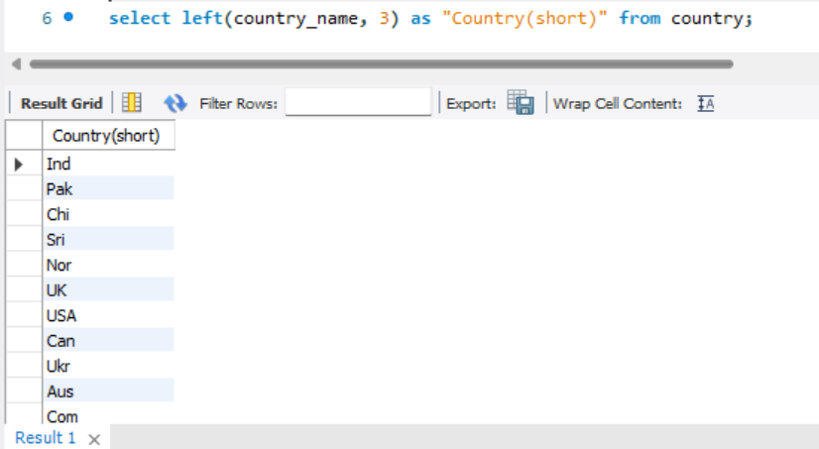

-- Concatenate first name and last name from Persons table:

select concat(fname, ' ', lname) as 'Full Name' from persons;

-- Count the number of unique country names from the Persons table:

select count(distinct Country_name) as Count_of_unique_countries from persons;

-- Print the maximum population from the Country table:

select max(population) as Max_Population from country;

-- Print the minimum population from the Persons table:

select min(population) as Min_Population from country;

-- Insert 2 new rows into Persons with Lname as NULL and count Lname in the Persons table:

select * from persons;

desc persons;

alter table persons

modify lname varchar(30) null;

insert into persons values

(27, 'Messi', null, 67868, 10.0, 678, 'UK'),

(28, 'Ronaldo', null, 73658, 9.8, 789, 'USA')

;

select count(lname) as Lname_count from persons;

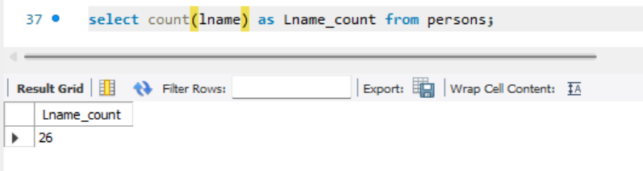

-- Find the number of rows in the Persons table:

select count(*) as Number_of_Rows from persons;

-- Show the population of the Country table for the first 3 rows:

select * from country;

select country_name, population from country limit 3;

-- Print 3 random rows of countries:

select * from country order by rand() limit 3;

-- List all persons ordered by their rating in descending order:

select Fname, Lname, Rating from persons order by Rating desc;

-- Find the total population for each country in the Persons table:

select Country_name, sum(population) as Total_Population

from persons

group by Country_name;

-- Find countries in the Persons table with a total population greater than 50,000:

select Country_name, sum(Population) as Total_Population

from persons

group by Country_name

having sum(population) > 50000;

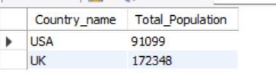

-- List the total number of persons and average rating for each country,

-- for countries with more than 2 persons,

-- ordered by the average rating in ascending order:

SELECT Country_Id, COUNT(*) AS Total_Persons, AVG(Rating) AS Avg_Rating

FROM Persons

GROUP BY Country_Id

HAVING COUNT(*) > 2

ORDER BY Avg_Rating ASC;

